**CIS 612 Big Data & Para Database System**

Name: - Kaushal Prajapati

CSUID: - 2789553

Submitted to: - Dr. Sunnie S. Chung

Lab: - Lab-3_3 Semi-Structured Data Processing with NoSQL Database Server Language Used: - Python

Interpreter: - PyCharm

Database: - Microsoft SQL , MongoDB

Description about project: -

1. Collected **349,765** tweets.
2. All data is regarding hashtag #Donald Trump, #Presidential Election, #Biden
3. Total Size of data 2.0GB.
4. Average size of each tweet: - 6.1kb
5. Used Python for parsing data.
6. Used packages: - Tweepy, pymongo, Json.
7. Used Twitter API.
8. Further Information is at last in conclusion.
9. Data fields parsed per tweet :- _id,created_at,id,id_str,text,display_text_range,source,truncated,in_reply_to_status_id,in_reply_to_status_id_str,in_reply_to_user_id,in_reply_to_user_id_str,in_reply_to_screen_name,name,screen_name,location,url,description,translator_type,protected,verified,followers_count,friends_count,listed_count,favourites_count,statuses_count,created_at,time_zone,geo_enabled,lang,contributors_enabled,is_translator,profile_background_color,profile_background_image_url,profile_background_image_url_https,profile_background_tile,profile_link_color,profile_sidebar_border_color,profile_sidebar_fill_color,profile_text_color,profile_use_background_image,profile_image_url_https,profile_banner_url,default_profile,default_profile_image,following,follow_request_sent,notifications,geo,coordinates,place,contributors,is_quote_status,extended_tweet,full_text,display_text_range,entities,quote_count,reply_count,retweet_count,favorite_count,entities,hashtags,url,expanded_url,display_url,indices,user_mentions,screen_name,name,symbols,favorited,retweeted,filter_level,lang,timestamp_ms.

Code [Python][Interpreter – PyCharm] :-

from tweepy import Stream  
from tweepy import OAuthHandler #For handling authentication  
from tweepy.streaming import StreamListener #For streaming tweets  
import json  
from pymongo import MongoClient  
import pymongo

**# Credentials**

access_token = '1240760950967480320-SKbpSG0JIJjEzEuvLYVyP6h3XxWJvr'  
access_token_secret = 'cvqKzSjXRwITluPal2Vem6z5BXu51pG8otf0KB7w3E6v1'  
consumer_token = 'gM8jEQL88qaTJQC8mJzlknASy'  
consumer_token_secret = '2zv6zcJ2hPFUDZboFikmOifnOzueLvuMmZvBio6yM9emzVN0dd'

**# Connecting to MongoDB database**

client = MongoClient()  
db = client.kaushal  
tweet_collection = db.CIS612_2  
tweet_collection.create_index([("id", pymongo.ASCENDING)], unique=True)

**# Tweets come in JSON format and then importing to MongoDB**class Listen(StreamListener):  
 def on_data(self, data):  
 tweet = json.loads(data)  
 tweet_collection.insert_one(tweet)  
 return True

**# Main Function**if __name__ == "__main__":  
 listener = Listen() # listener object of Listener class  
 authentication = OAuthHandler(consumer_token, consumer_token_secret)  
 authentication.set_access_token(access_token, access_token_secret)  
 stream = Stream(authentication, listener) # stream object with authentication

stream.filter(track=["Presidential Election", "Donald Trump", "Joe Biden"]) # filtering the tweets with

MongoDB Queries: -

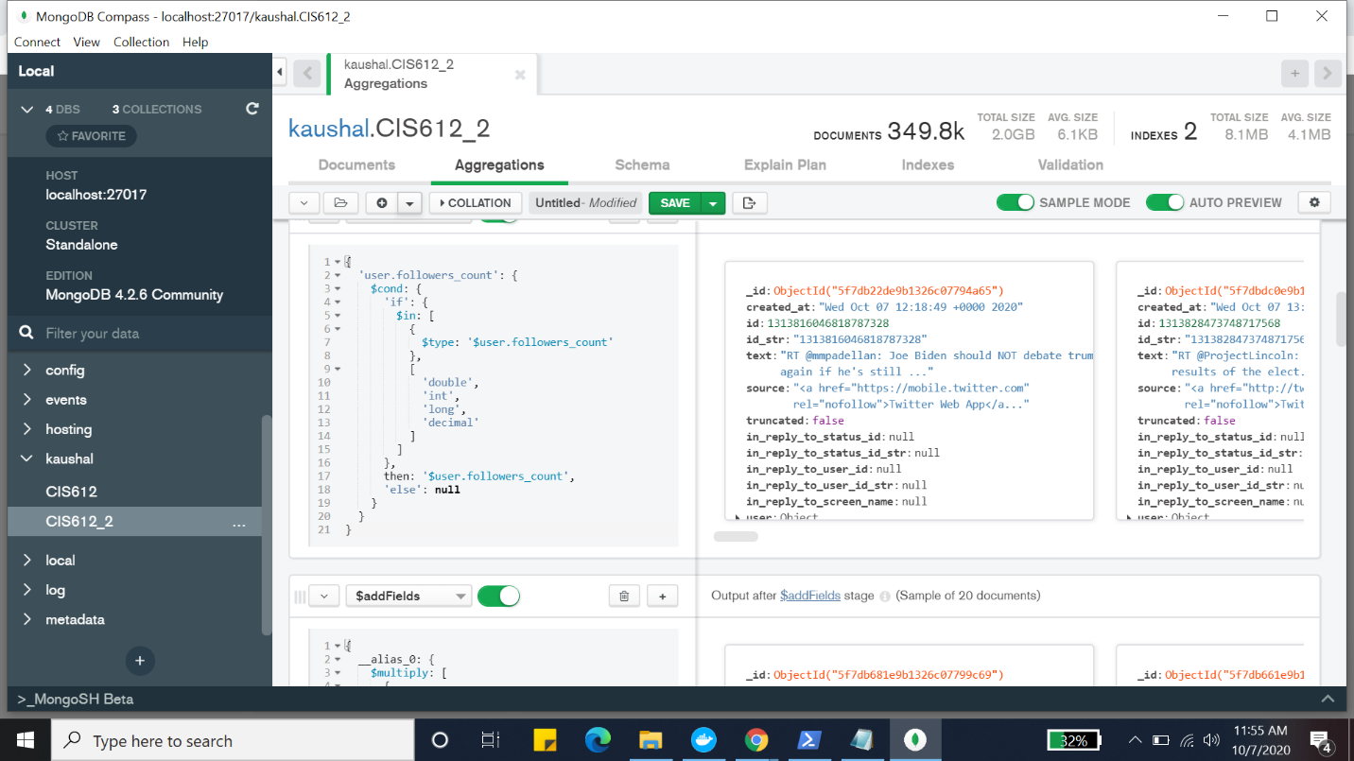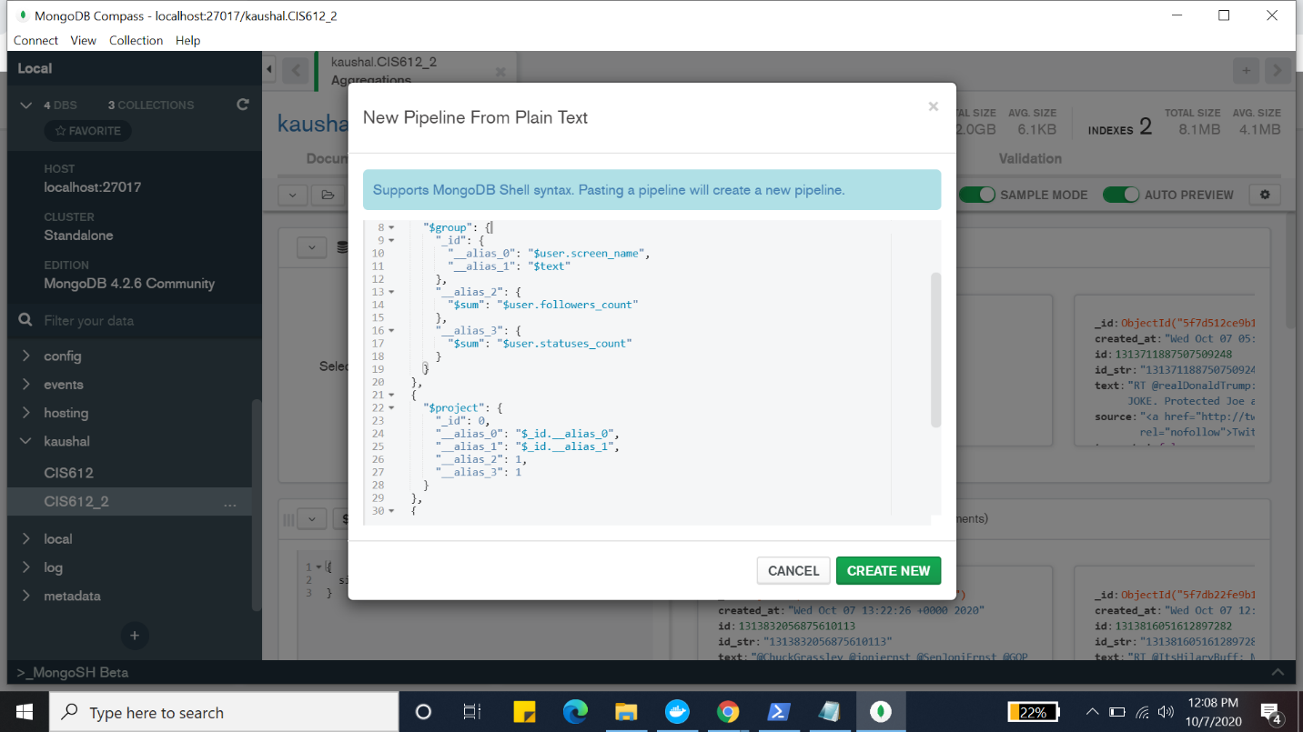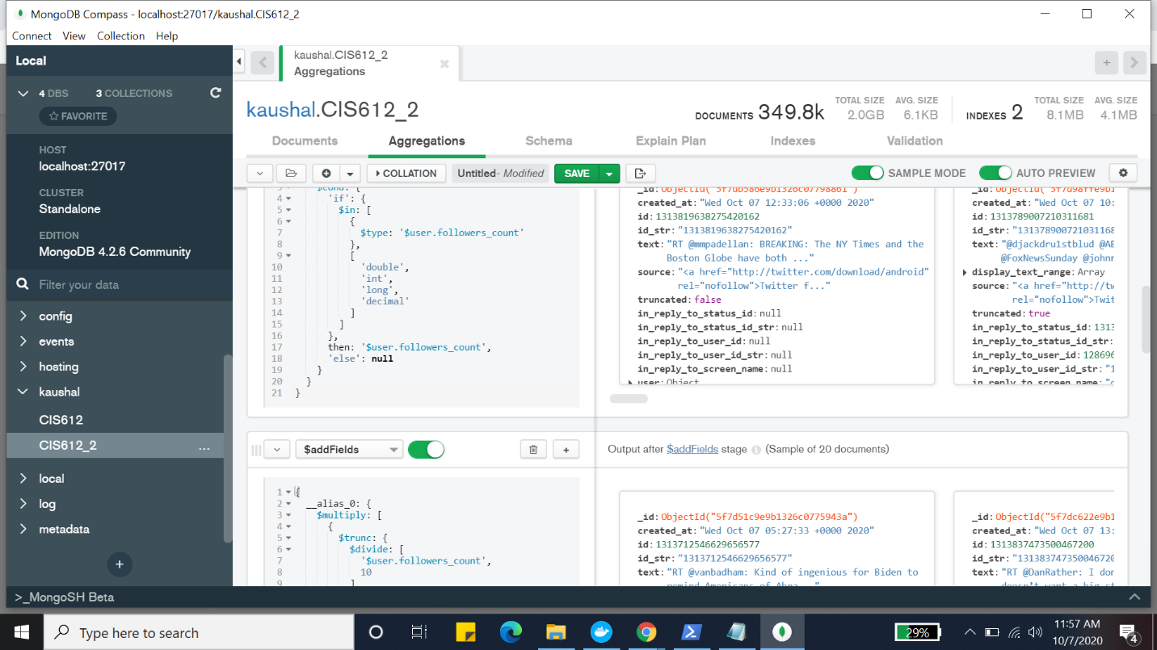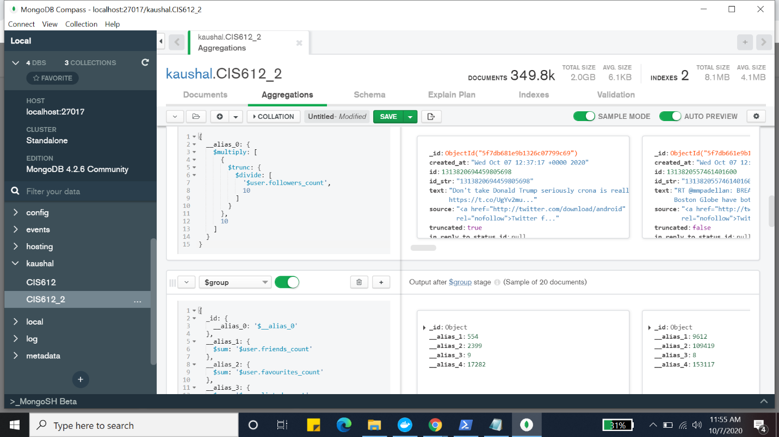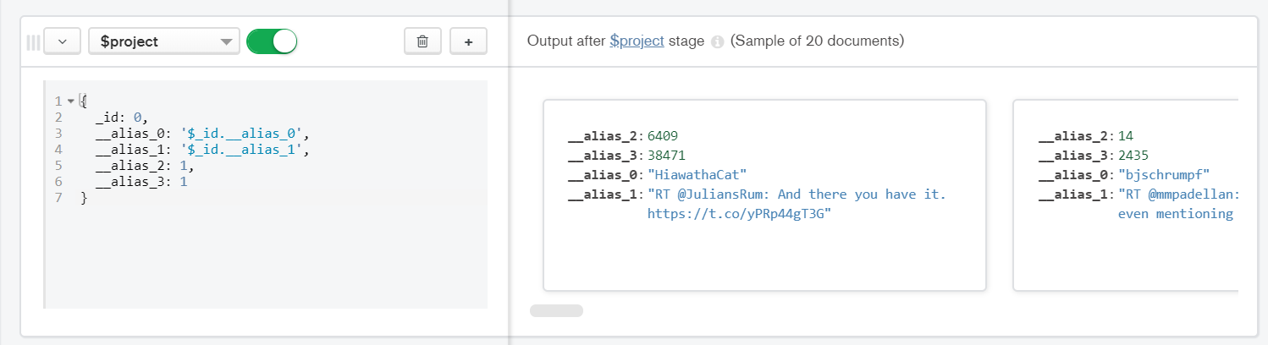

MongoDB Charts :- 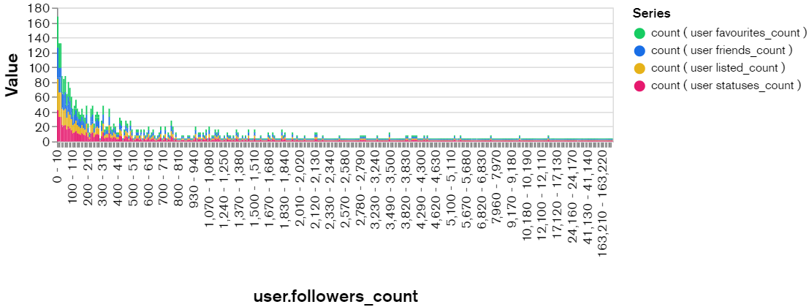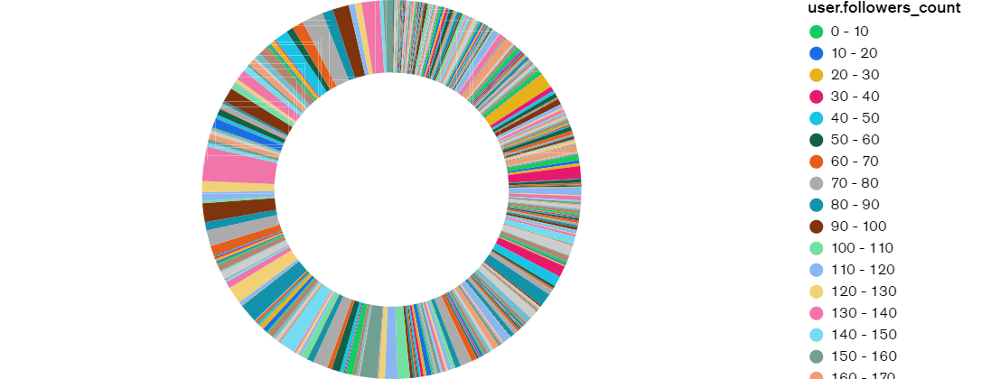

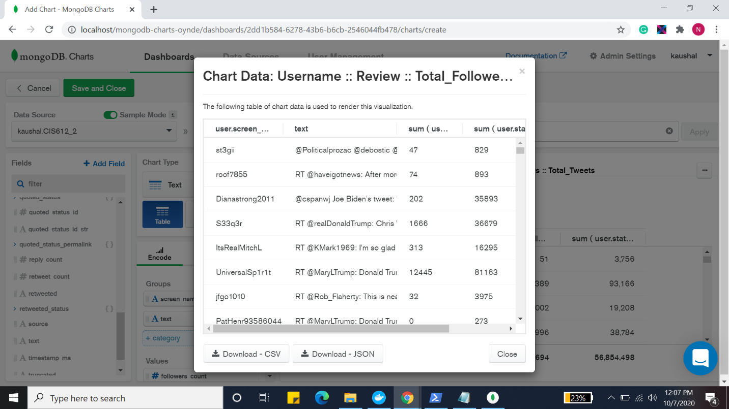

I Used Docker for MongoDB Charts: -

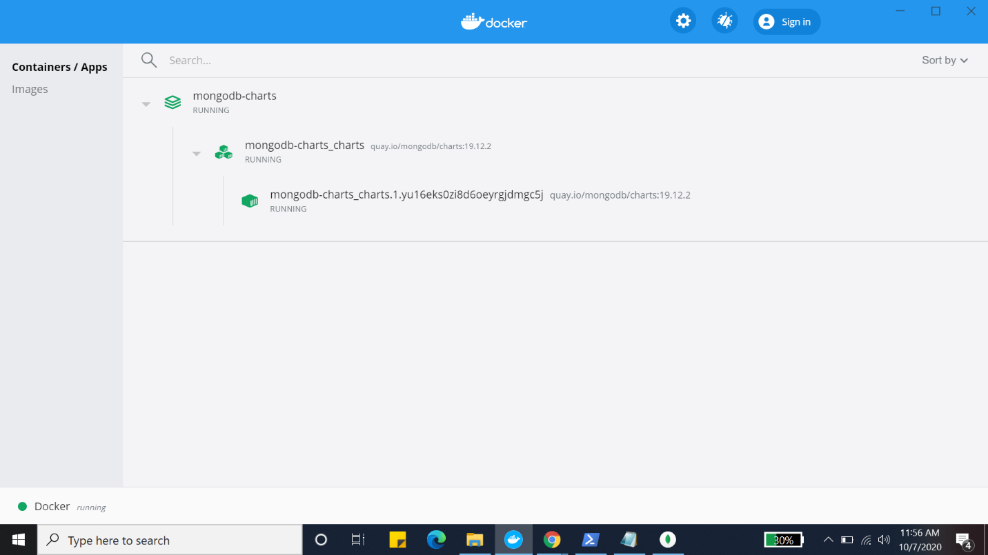

Some Screenshots of Database: -

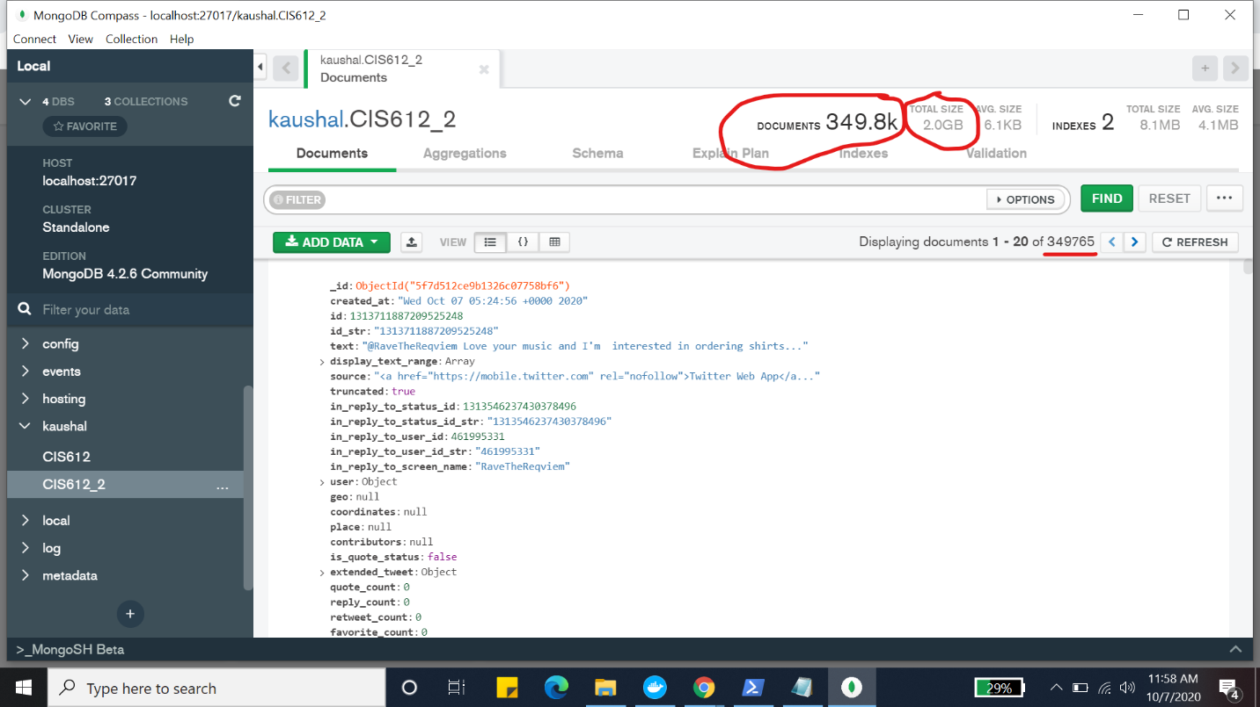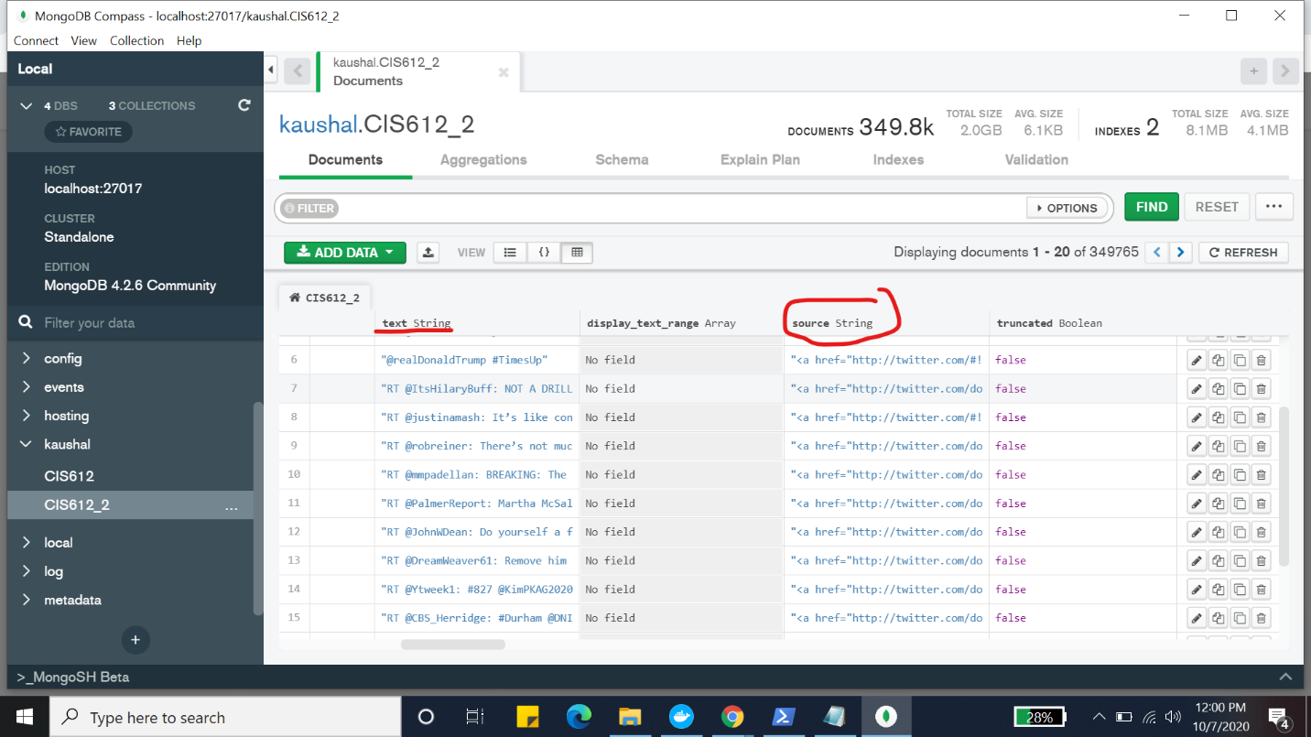

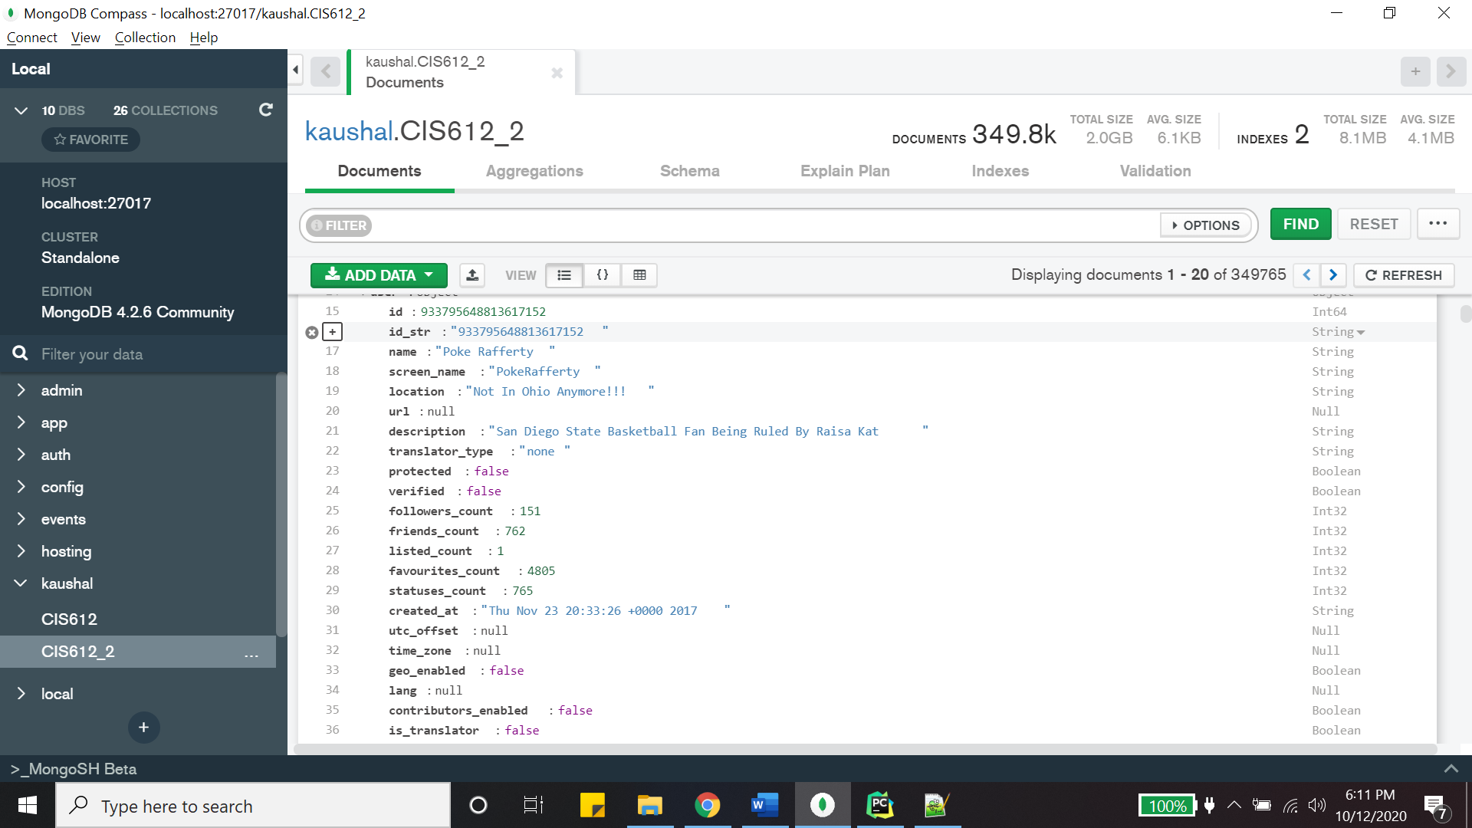

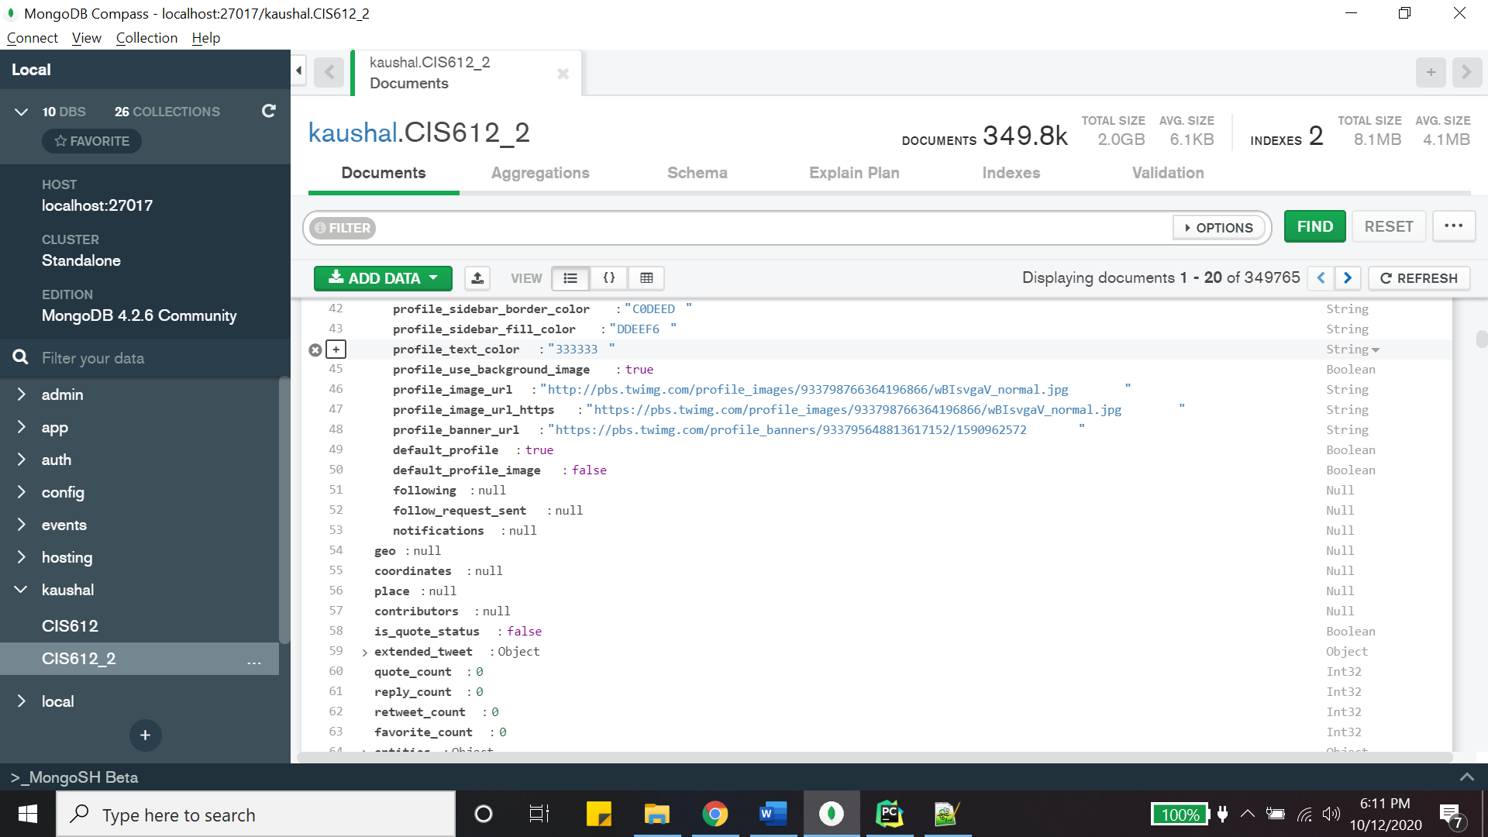

Dividing Tweets including text: - Trump , Biden.

***This Tweets Includes: - Donald Trump***

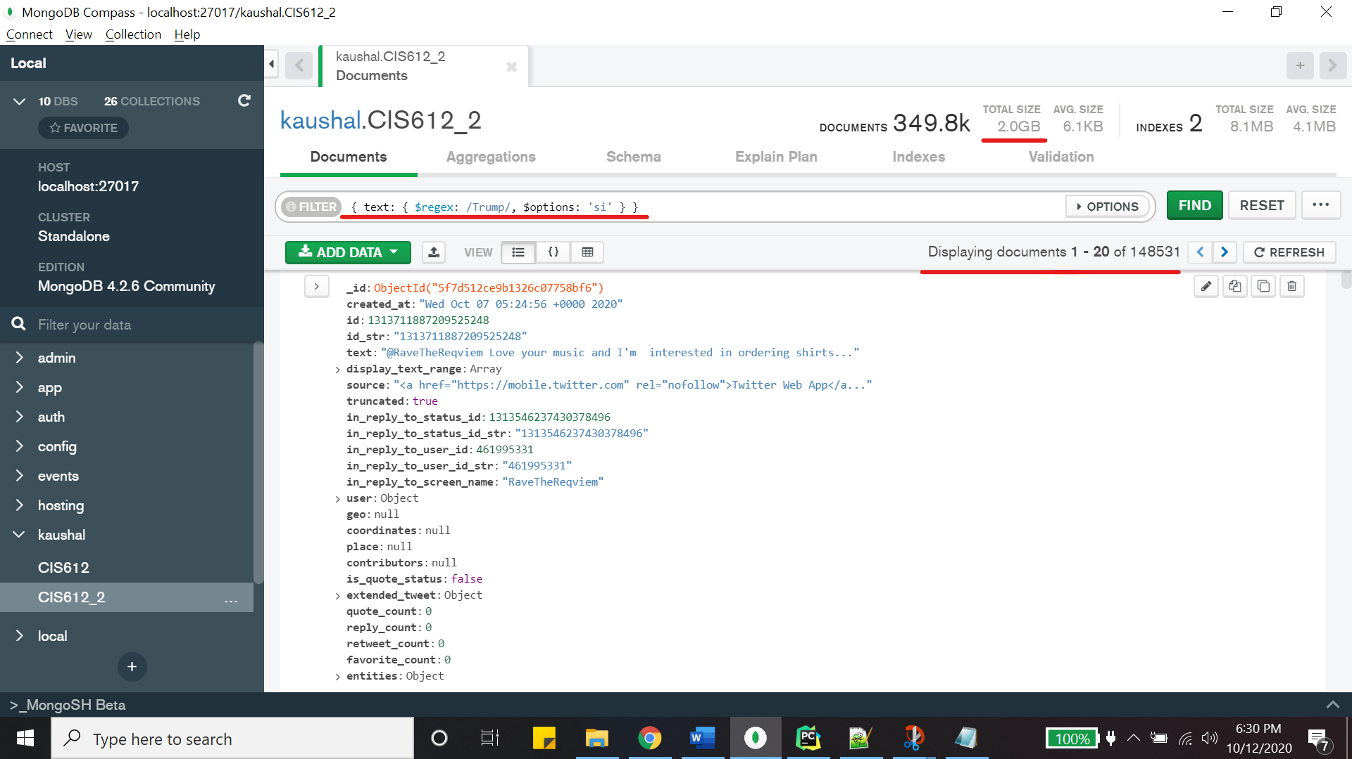

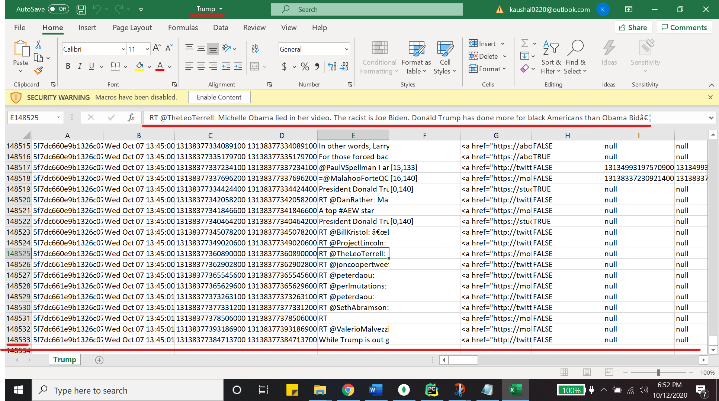

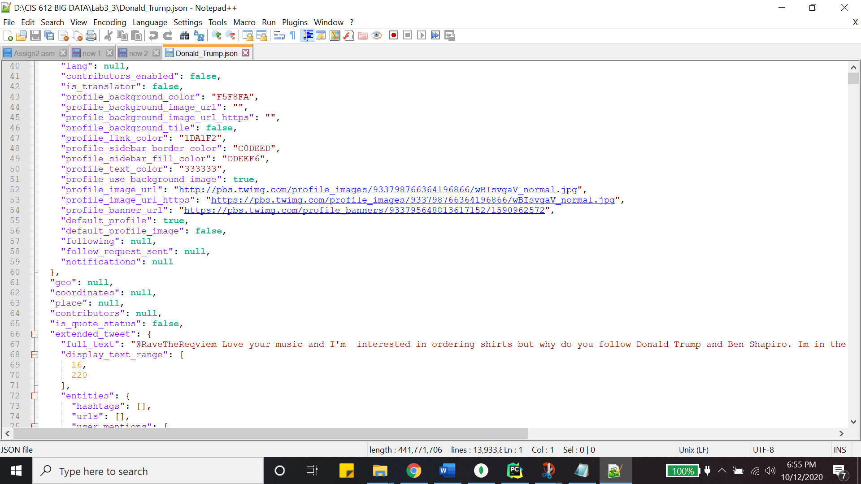

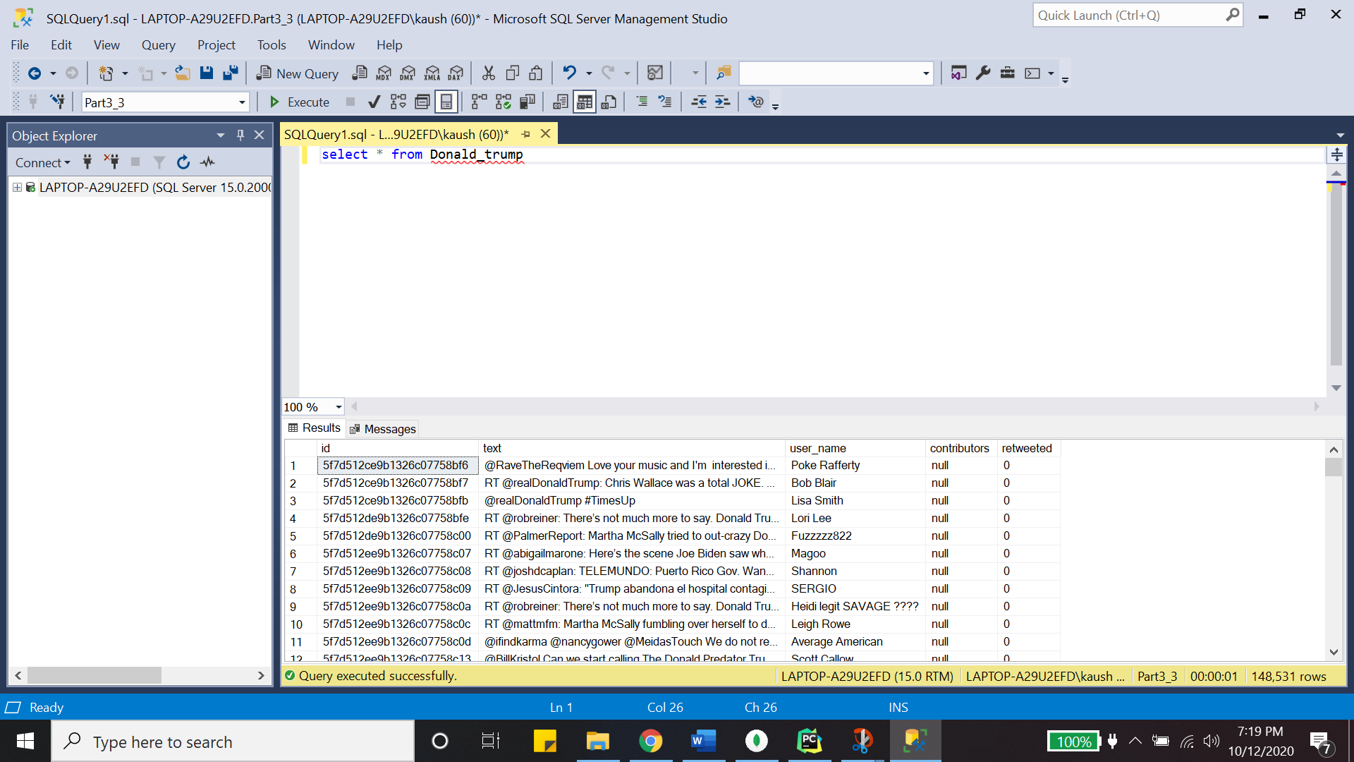

***This Tweets Include: - Joe Biden***

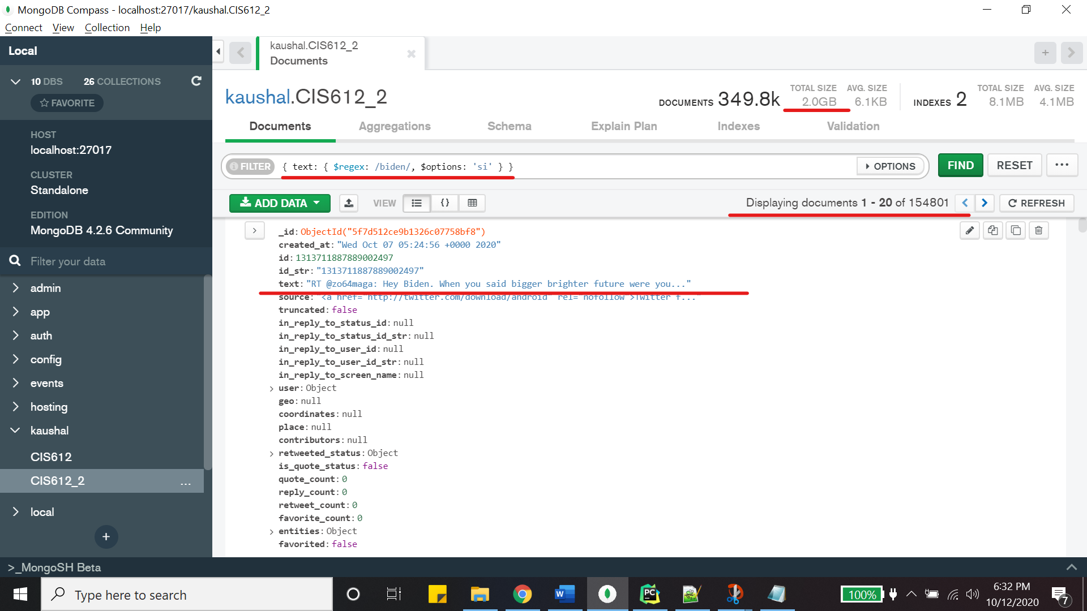

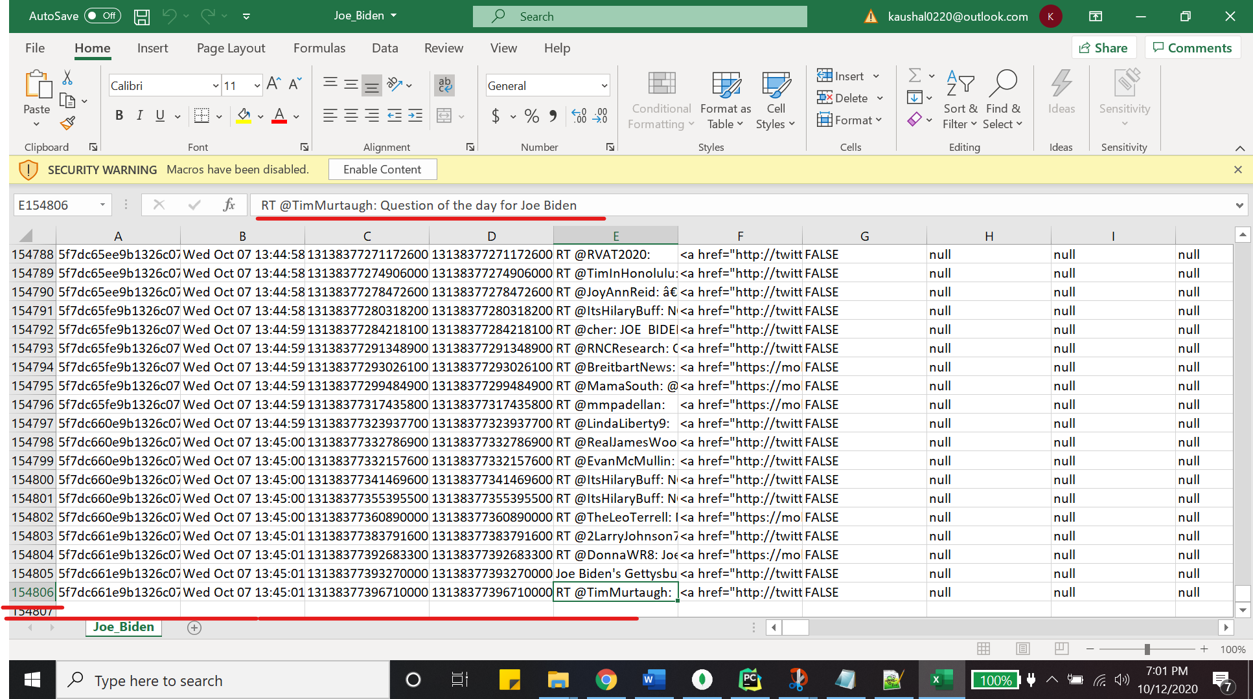

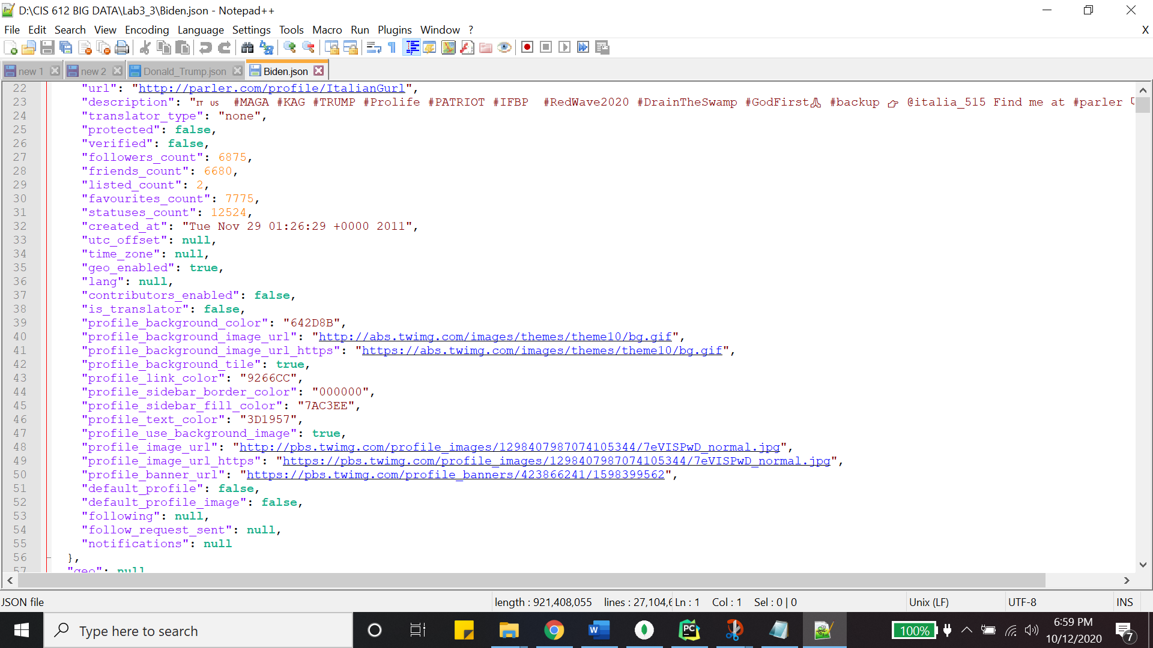

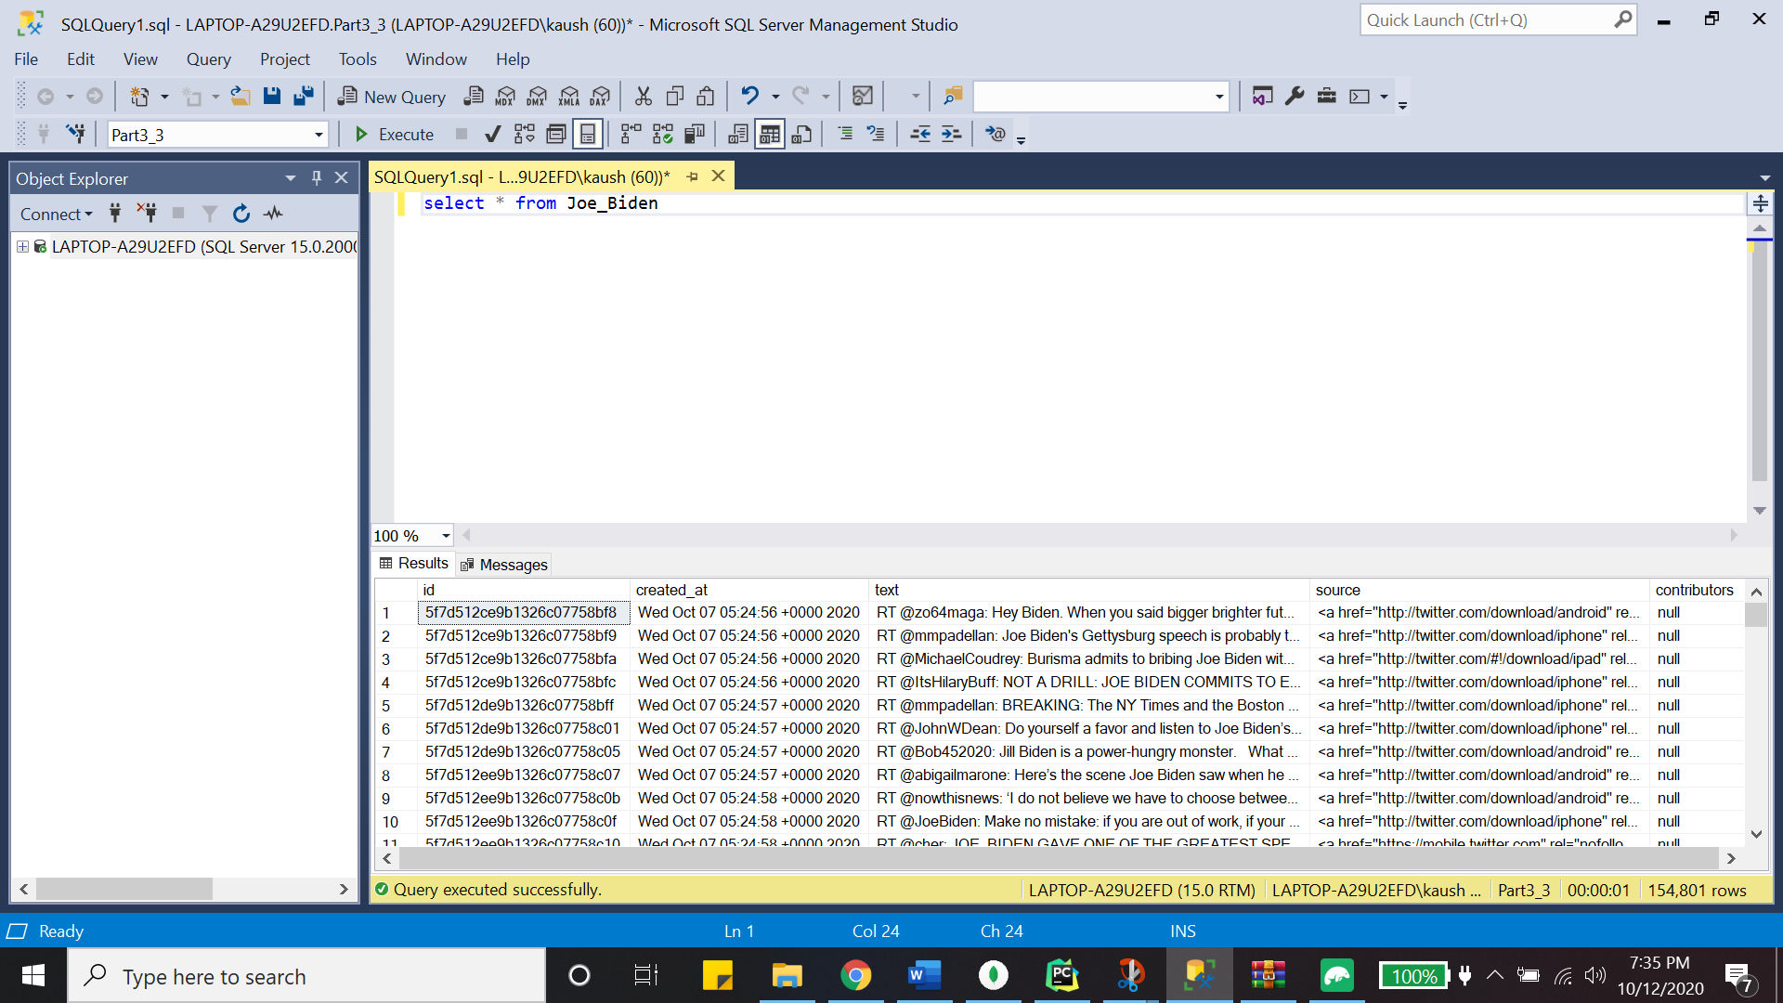

Mongo Queries: -

use kaushal;

db.getCollection("CIS612_2").find(

{

"user.followers_count" : {

"$gte" : NumberInt(87)

},

"user.friends_count" : {

"$gt" : NumberInt(117)

},

"user.listed_count" : NumberInt(1)

}

);

(2)

use kaushal;

db.getCollection("CIS612_2").find(

{

"user.profile_background_color" : "F5F8FA",

"user.profile_text_color" : "333333"

}

);

Conclusion: -

* Made the application as a REST API application in Python to make the process automatic for big data processing.
* Retrieve all the messages related to Donald Trump in MongoDB Queries and saved them.
* Transform each twit in JSON structure to CSV/TSV to Create a Relational table in a SQL Server. [ All Screenshots are included]
* Found the basic info like how many messages with $Match, Aggregation pipelining, and $Group [Screenshots included in this report above].
* Collected all the data in MongoDB.
* Used and Learned Docker for MongoDB Charts.
* Coding Language – Python, Interpreter – PyCharm.
* Project Completely done with all the requirements and Extra Credit Part.